Lochdonhead Primary School

Online Safety Newsletter: June 2019
Use the S.H.A.R.E checklist

The government have released a S.H.A.R.E checklist to help you spot misleading news or information online to avoid it being shared.

When incorrect information is shared it can have serious consequences, for example it can lead to health scares and hoax stories.

So before you like, comment or share online, use the checklist which is available here:
https://sharechecklist.gov.uk/

YOLO: Q&A App (17+)

Currently at the top of the App Store chart, YOLO: Q&A is a social networking app that is used with SnapChat (although not affiliated by Snapchat). YOLO is rated as 17+ in the app store, which means you should be at least 17 years old to download this app.

YOLO is an acronym for ‘you only live once.’ In YOLO, users request to "send me anonymous questions" which then posts the request in Snapchat (via their Snapchat story or to a group of friends). All questions are then sent via YOLO anonymously.

The NSPCC have issued a warning about this app as it can clearly be misused to send abusive or upsetting messages (Source: https://www.bbc.co.uk/news/technology-48214413).

Due to the nature of this app we would highly recommend that the age rating of this app is adhered to.

More information
- Safer Schools have produced this helpful YouTube video which summarises what YOLO is: https://www.youtube.com/watch?v=RQVRkMA9KZU
- More information about different anonymous messaging apps available and top tips can be found here: https://www.net-aware.org.uk/news/anonymous-messaging-apps-whos-asking/
Instagram – let’s keep it private

Whilst you should be over 13 years of age to have an Instagram account, if you choose to allow your child to have an account, make sure their account is set to private. This means that only followers that your child knows and accepts will see what they post.

Looking for a new game or app to try?

Fe is rated by PEGI as 7+ and is available on Switch, PS4, Xbox One and PC. It is an adventure game in which the player controls Fe, a fox-like creature.

The LEGO® Life app is suitable for 5+ and offers a safe environment for younger children to build and share their Lego creations. It introduces children to the positive elements of social platforms, such as being able to share with family and friends and comment (all moderated) and like other people’s creations.
Jumbo app

The Jumbo App is currently only available on iPhones but it is a great way to manage your privacy settings on Facebook, Google Search, Twitter and Alexa (Instagram to be added shortly).

For Twitter, it will make your tweets exist online for a time period chosen by you (and then they’re saved on your iPhone). For Facebook, it will help you modify your privacy settings easily. For Google, you can clean old searches and for Alexa you can clean all your Alexa voice recordings. Jumbo cannot access any of your personal data, or track your personal behaviour.

Download the app here: https://itunes.apple.com/gb/app/jumbo-privacy/id1454039975?mt=8

Further information available here:
https://www.jumboprivacy.com/
Location Services

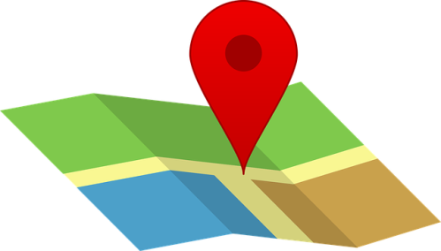
Lots of apps that we use can monitor our location, allow us to ‘check in’ at a location or share where we are.

It is important to talk to your child about how they use the location settings within apps e.g. checking in at home or at schools shows people where you live/go to school and tells people when you are at home/not at home. Reinforce that this is personal information. It is particularly important to stress that it is risky to share their location if this can be seen by strangers.

Check your settings:
You can control which apps can see and use your location.
- Android: https://support.google.com/android/answer/6179507?hl=en-GB
- Apple: https://support.apple.com/en-gb/HT207092

Snap Map
One example of an app that uses your location is Snapchat through the Snap Map. The Map lets users see where their friends are if a friend has chosen to share their location at any given time. You can change your location setting for Snapchat by following these instructions: https://support.snapchat.com/en-GB/a/snap-map-location-settings

More information:
https://www.childnet.com/parents-and-carers/hot-topics/location-services

Talking Angela app (4+)
Angela is a talking cat who copies what you say and you can give her presents, select different
outfits, record her and then share the video of her with friends.

The app is rated as 4+ by the App store but you should be aware that if the app is not in child mode (this is set when you input the date of birth when first using the app) then the user can open up YouTube (when the video button is pressed in the app) in the browser to show Talking Angela’s videos which are age appropriate but obviously the child is then on YouTube so can potentially navigate to other videos that may not be appropriate (you should also be 13+ to use YouTube). If the app is in child mode then the videos that pop up are curated to a selected few and the child stays within the app but users are able to post comments on the videos (if they have an account) and see all comments regardless of having an account or not.

There was false news circulating about this app but it has since been shown to be a hoax. Originally users could ask Angela questions but this functionality has been removed.

