Mathematics in Ulva and Lochdonhead Primary Schools
February 2015
The Mathematics Principles and Practice papers state, ‘Mathematics is important in our everyday life, allowing us to make sense of the world around us and to manage our lives. Using mathematics enables us to model real-life situations and make connections and informed predictions. It equips us with the skills we need to interpret and analyse information, simplify and solve problems, assess risk and make informed decisions.’
Significant Aspects of Learning
We make use, in our planning, of the significant aspects of learning in numeracy and mathematics to provide effective breadth, depth and progression.
The five significant aspects of learning in numeracy and mathematics are; -
- Use knowledge and understanding of the number system, patterns and relationships,
- Use knowledge and understanding of measurement and its application,
- Use knowledge and understanding of shape and space,
- Research and evaluate data to assess risks and make informed choices,
- Apply numeracy and mathematical skills.
The main resource we use at Lochdonhead and Ulva Primary Schools is Heinemann Active maths with associated software. This maths programme is used to ensure our learning is active and that there is progression within each of the significant aspects of learning. However, at all times, we build opportunities for pupils to link mathematics into other areas of our curriculum, providing learning in context.
Applying Skills
‘A key feature of the mathematics framework is the development of algebraic thinking from an early stage’, Mathematics Principles in Practice. We do this in a variety of ways – we explore patterns, we explore the balancing of equations, we use ICT function machines and create familiar symbols to represent unknown values in a calculation before using letters.
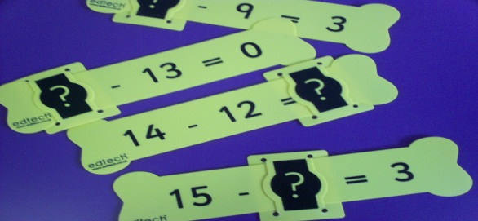
Use of I-pads to provide challenge and enjoyment
Resources which promote algebraic thinking

As learners progress, our learners demonstrate an increasing sophistication in their ability to;
- Interpret questions,
- Select and communicate processes and solutions,
- Justify choice of strategy used,
- Link mathematical concepts,
- Use mathematical vocabulary and notation,
- Use mental agility,
- Reason algebraically,
- Developing confidence in taking risks, asking questions and exploring alternative solutions,
- Determine the reasonableness of a solution.
We use any wrong answers or misconceptions as points of learning, providing opportunities to improve and deepen pupils’ understanding. Problem solving is at the heart of all our learning and teaching and we regularly ask questions, such as, ‘What would happen if……’ to develop mathematical thinking. Examples of this are used in our cross curricular topics in forest schools, collecting and organising resources and outside learning and We-do Lego building.
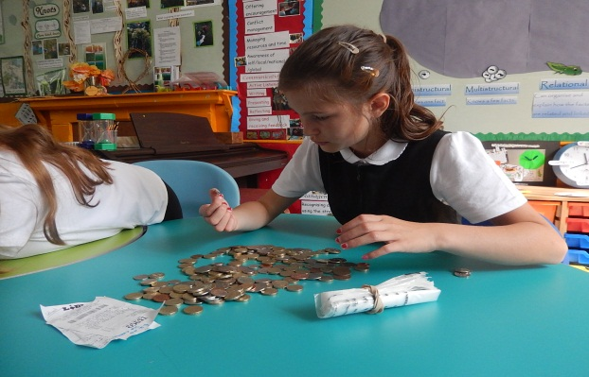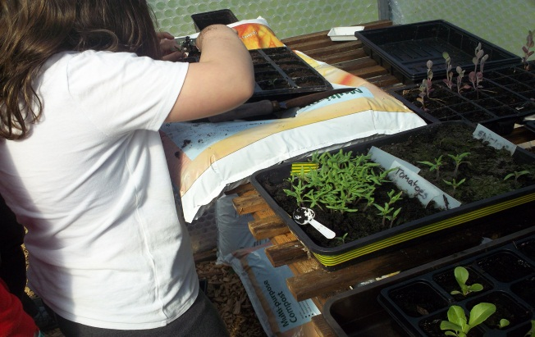
Estimating, capacity, measuring in our greenhouse
We use relevant contexts for money handling

Breadth in Mathematics
We provide many opportunities for pupils to demonstrate their confidence and application of mathematical skills across our curriculum. Examples of this are in the classroom with I-pad games, loop cards, ball gamers and computer games to provide mental maths challenges. We use a vast array of quick maths game activities such as bingo with the whiteboard. We use board games and dice games, quizzes and speed races.
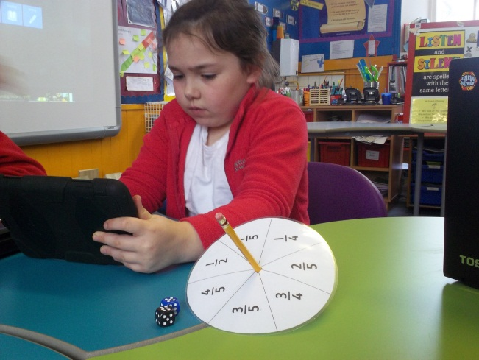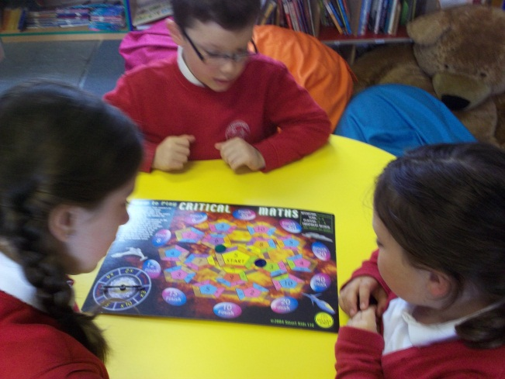
Maths challenge in groups
Independent challenge with fractions

Our pupils demonstrate breadth in mathematics when they;
- Work confidently with an increasing number of connected experiences and outcomes,
- Identify the mathematical ideas and concepts required to interpret questions,
- Use an increasing range of mathematical language and notation, formula and equations,
- Use an increasing range of mathematical tools.
Challenge in Mathematics
Our learners are provided with challenge using a range of approaches including;
- Working with open ended questions and tasks,
- Providing tasks which increase mental agility,
- Providing tasks which require an extended range of mathematical knowledge in tasks,
- Tasks which require interpretation using increasingly complex numerical information and using this to draw conclusions, assess, make reasoned evaluations and informed decisions,
- Asking pupils to communicate their understanding by articulating ideas, approaches and processes with increasing clarity, both orally and in written form,
- Developing [problem solving capabilities and critical thinking skills.
Challenge is built into our planning, providing an appropriate range of opportunities across the curriculum. Examples of these challenges are the Sum dog competition where we compete against other Argyll and Bute schools. IDL learning can provide opportunities for learning in context for example measuring bird boxes and foot paths for our conservation garden and counting money of LCC cafe. Pupils regularly practice their multiplication table and race against the clock to improve their speed and accuracy of recall.
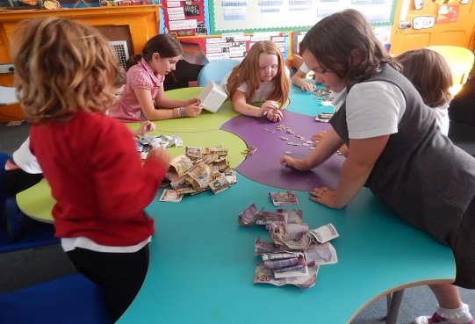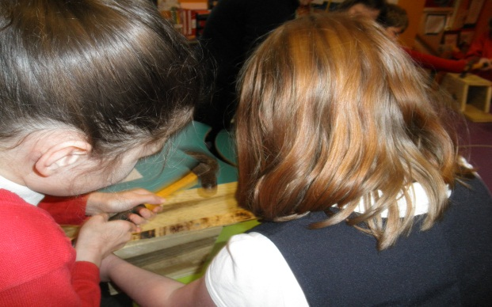
Precise measuring for making our bird boxes
Counting our takings from our Community Cafe

Assessment in Mathematics
We gather evidence from day to day learning as well as using specific assessment tasks, building on the principles of Assessment is for L earning, ensuring pupils understand the purpose and relevance of what they are learning. Pupils show evidence of their learning and progression of their skills both by working collaboratively and independently as they observe, explore, experiment and investigate mathematical problems. Our assessment approaches identify the extent in which our pupils apply their skills in learning. When we assess, examples of questions we ask are;
- Do they relish the challenge of number puzzles, patterns and relationships? Can they explain increasingly more abstract ideas of algebraic thinking?
- Can they successfully carry out mathematical processes and use their developing range of skills and attributes? As they apply these to problems, can they draw on skills and concepts previously learned?
- As they tackle problems in unfamiliar contexts can they confidently identify which skills and concepts are relevant to a problem? Can they apply their skills accurately and then evaluate their solutions?
- Can they explain their thinking and demonstrate their understanding of 2D and 3D objects?
- Can they evaluate and make informed decisions?
- Are they developing the capacity to engage with and complete tasks?
Examples of the range of assessment are pupils work is recorded in individual maths folders, question bank assessments, I-pads mental maths photos, self-assessment using success criteria displayed on the maths wall. Skills book is used to set targets and record feedback.
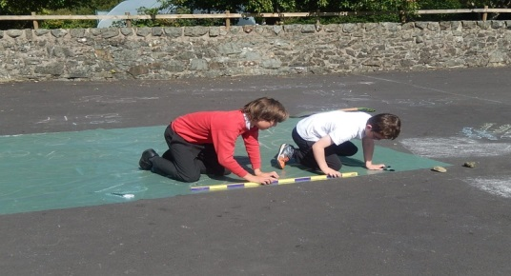
Can the pupils select an appropriate measuring tool and provide a reason for choice?

