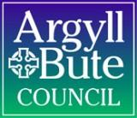

PARENT HANDBOOK
Secondary – S1 – S6

Dear Parent / Carer
This handbook is for you to keep as a reference for your child’s education within Argyll and Bute schools. It details aspects of school life that we need you to be aware of and sign your agreement to; for example internet use and publishing your child’s photos and artwork. This is because current data protection legislation has implications for schools as well as other areas of society. In addition, there are Child Protection guidelines, which affect school practice.

The handbook will provide information to help you decide whether to give your consent and the form at the end of the handbook allows you to tick each consent separately. The handbook is designed so that you can keep the sections detailing the consent and the sign off form at the rear is completed and passed to the school. Your consent choices will be recorded in your child’s record in school and will move with them through secondary school. You can, of course, give or remove consent at any time throughout your child’s school life by contacting the school in writing.

Contents
Using the Internet, Email* and Glow in Argyll and Bute educational establishments 3
Responsible use agreement 3
Skin Protection 4
Media Approval 4
Copyright Approval 4
Short Visits 4
Cashless Catering 5
National Entitlement Card 6
Parent/Carer Consents 7

Using the Internet, Email* and Glow in Argyll and Bute educational establishments

Responsible use agreement
Purpose of a responsible use agreement
A responsible use agreement provides the education service and its registered Internet and Glow users with a set of agreed boundaries which both parties will agree to work within. The agreement guarantees that all users are aware of the security procedures that are in place for their own protection and their own responsibilities when accessing the Internet and Glow. The responsible use agreement applies to all pupils and a similar policy for Council staff applies to all school staff. The terms and conditions of a responsible use agreement are as follows.

Using the Internet, Email* and Glow
When accessing the Internet all pupils must abide by the following rules.

All users should:
- access Internet pages which are directly related to the current task as identified by the member of staff in charge;
- save/download information related to the current task as identified by the member of staff in charge;
- report instances of misuse to the member of staff in charge;
- ‘logout’ at the end of each Internet or Glow session;
- treat all equipment and other users with respect.

Users should not:
- tell anyone their login ID or password;
- use portable storage devices brought from out with the school;
- send illegal or defamatory material; further information is included in the accompanying acceptable use policy documentation;
- receive illegal material or material which is offensive or defamatory without informing the member of staff in charge;
- read emails intended for others;
- create rude or abusive emails about other people.

Personal safety
- never tell anyone you meet on the Internet your home address or your telephone number.
- never tell anyone you meet on the Internet your school’s name or phone number, unless your teacher specifically gives you permission.
- never send anyone your picture, credit card or bank details.
- never give your password to anyone – even a best friend.
- never arrange by email to meet anyone you don’t know in person.
- never respond to nasty, suggestive or rude emails.
- always tell a member of staff in charge if you see bad language or distasteful pictures while you are online.
- always be yourself and do not pretend to be anyone or anything you are not.
- always remember if someone makes you an offer that seems too good to be true, it probably is.
- always delete attachments from strangers without opening them; they may contain viruses that can damage your machine.
- never open an email if you are suspicious of its source.

Please note*
Email is for Secondary Pupils only. Privacy of electronic mail (email) is guaranteed. However those who administer the system on behalf of the education service have access to all mail messages and have the right under legislation to investigate any user activities where suspicious use of the system is identified. All communications and information accessible via the network should be assumed to be private property of those who created it and therefore protected by copyright legislation. Security on any computer system is high priority. If a user identifies a security problem on the network they must notify the school network manager immediately. They should not demonstrate the problem to other users. Any user identified as a security risk may be denied access to the network. Argyll and Bute Education makes no warranties of any kind, whether expressed or implied, for the service it provides and specifically denies any responsibility for the accuracy or quality of information obtained through its network.

Skin Protection
Sun Cream and Midge Repellent
Your child’s skin may be affected by exposure to the sun, especially over the lunchtime period and other outdoor activities. It is a good idea for your child to wear a sun hat. If they have one, please put it in their school bag.

The school is restricted in what it can apply or administer to your child, however, if you wish to send in sun-cream/block/midge repellent we can help them apply it. We have factor 50 sunblock in school which we can put on the children. If you do not wish these creams to be used on your child, please complete the Skin Protection consent section at the rear of this handbook.

Media Approval
During the course of the school year, pupils’ achievements are celebrated in a variety of different ways. School websites, Facebook and Twitter facilities are especially good at highlighting and celebrating our youngster’s achievements and successes. Additionally the local press often request permission to feature stories on youngster’s sporting achievements and other notable school events.

Increasingly, children can be invited to represent the school at local and national events that may feature in the national press, radio or television.

Where large group photographs of youngsters feature in any publication it is the norm for individual pupils not to be named. However, individual / small groups of pupils may be named where their specific achievements are featured in the media. Group and individual photos give a flavour of school life and enhance the publications concerned. Children are also pleased to see their pictures used in this way. Some schools use a camera, either still or video, within the classroom or on educational outings. Photographs and videos of pupils may be used on the following manner:

- In the school’s handbook, newsletters or on the school website*
- In Argyll and Bute Council publications and on the Council website*
- In Council exhibition material, plasma screens etc.,
- Kept indefinitely and used by the Museum, Library or Archives as part of their collection
- Press coverage
- School and Council social media sites e.g. Facebook and Twitter
- Reviewing and improving professional practice
- Filming of school concerts and school events

Copyright Approval
Children’s work is often displayed in the classroom and schools corridors. In addition, work is often displayed in other Council buildings as part of exhibitions.

Short Visits
During the pupil’s school life teachers will be organising some local off-site curricular activities which will take place in the proximity of the school. Pupils will be supervised by their class teacher during these visits. Class teachers will obtain approval from the Head Teacher for each visit. Please note that this consent form is for short local visits only. We will ask you at the appropriate time for permission for any longer visits and any visits that require transport.

Cashless Catering
If your child is attending one of the nine Cashless Catering Secondary schools or a Joint Campus school in Argyll and Bute, they will be able to take advantage of the Cashless Catering system.

Pupils will require a National Entitlement Card (NEC) to access their school meal accounts. If you choose not to give consent for an NEC your child will receive a temporary cashless catering card. The school may make a charge for this card.

The Cashless Catering account will have to be credited with money prior to use. To enable pupils to do this there are “top up” units conveniently placed within the school where pupils can deposit cash to credit their accounts. Please check with your local school as to what coins/notes are accepted. Alternatively there is an online payment facility available on the council website, which will allow parents/guardians to make payments to their child’s cashless catering account using a debit or credit card.

Parents/Guardians will be contacted individually with details of how to use this facility.

Kitchen staff will swipe a pupil’s card through terminals in the dining area to record automatically, all purchases made by the pupils. This process will debit the cost of the transaction from the balance remaining on the catering account.

The card offers significant advantages over traditional cash payment. Some of these are:

- Use of a payment card cuts out the need for children to carry cash on a regular basis.

- Pupils entitled to free meals use the cards in the same way as everyone else. Any stigma, which youngsters may feel about free meals, is completely removed.

- Pupils are responsible for their own "canteen debit card" and balance, encouraging self-discipline.

- Restrictions can be set to prevent your child from buying particular food - very important in cases of allergies or other dietary conditions or even just to encourage healthier eating.

- If pupils carry cash less often, theft and bullying can be reduced or eliminated.

- Since the monetary value attached to the card is held on a central computer and not on the card itself, once a lost or stolen card has been reported to the school it can be disabled, making it unusable for further purchases.

A temporary card will be issued to allow the cardholder to access their account until a replacement can be issued. Some schools charge for replacement cards, please check with your local school for more details.

(If you choose not to consent to a cashless catering card your child won’t be able to purchase any food/drinks within the school – a cashless catering card is still required if your child is receiving Free School Meals)

PUPILS WILL RECEIVE THEIR NEC/TEMPORARY CASHLESS CATERING CARD WHEN THEY RETURN TO SECONDARY SCHOOL IN AUGUST.

National Entitlement Card

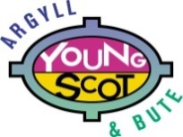
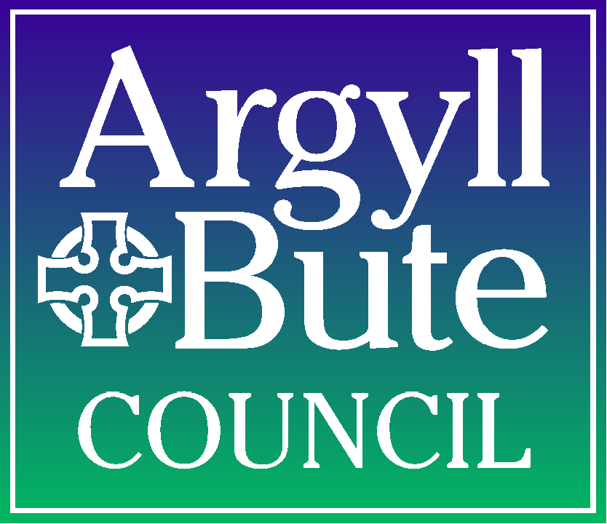
Application for a National Entitlement Card

About the National Entitlement Card
As part of their Customer First programme the Scottish Government, local councils and other agencies have introduced the National Entitlement Card (NEC) making it easier for people to access public services across Scotland. Your NEC will also be used as your Cashless Catering card in schools operating the cashless catering system.

Information on Data Sharing
We may wish to share your personal details with departments and agencies of the council, other Scottish councils, Young Scot, the Scottish Government and their agencies, and the Registrar General.
Sharing information with these bodies will not result in you receiving junk mail. This will ultimately benefit you and us by:
- Ensuring your personal details are correct and kept up-to-date wherever these bodies hold them
- Helping us identify other public services that you may be eligible for now, e.g. concessionary travel
- Allowing us to contact you automatically if you become eligible for new services in the future
- Allowing us to pass your basic information to other departments to make it simpler and quicker for you to apply for their services
- Avoiding us all repeatedly asking you for the same information when you apply for new services
- Avoiding you having to provide us with the same documents to prove you are eligible for new services
We need your permission to share your details to do all this. You must put an X in the box of the application form to withhold your permission for us to share your data among these organisations.

Data Protection
The National Entitlement Card and the entitlements offered are administered by the Scottish Government and Scottish local authorities or their agents. The Council is the ‘data controller’ under current data protection legislation.

If you have ticked any of the boxes on the application form we will not be able to share your data and you will have to apply in full to receive new services on your card.

Young Scot
Young Scot is the national youth information agency for Scotland and is a registered charity. Your new National Entitlement Card will have Young Scot branding, giving you access to all of the Young Scot information services, as well as discounts and special offers in over 1,800 places in Scotland and in over 200,000 places in 42 European countries. The new card will also have the PASS hologram on it, meaning you can use it as a proof-of-age card across the UK. You can find out more information at: www.youngscot.org

Further information about National Entitlement Cards can be found on their website http://www.entitlementcard.org.uk/.

Parent/Carer Consents
(please return completed form to school office)

Pupil Name:
School Name: |  | Date of Birth:

Using the Internet, Email and Glow in Argyll and Bute educational establishments
Responsible use agreement
As the parent or carer of this pupil, I understand that access to the Internet and Glow is required for educational purposes and that my child will automatically receive access to the Internet and Glow. Argyll and Bute Community Services: Education has taken precautions to prevent access to inappropriate material, but cannot restrict access to all potentially offensive materials and I accept they cannot be responsible for materials acquired on the network.
 | YES | NO
Email (secondary pupils only)
Internet Access
GLOW access

Skin Protection
I give consent for my son/daughter to: | YES | NO
have sun cream applied if supplied by the school
have sun cream applied if supplied by parent
have midge repellent if supplied by the school
have midge repellent if supplied by the parent
have stage makeup/face paints applied by the school

Copyright Approval
 | I give consent for my son/daughter to have work displayed:  In school classrooms/corridors | YES | NO
 | in other Council buildings as part of exhibitions
Media Approval
I give consent for my son/daughter to be included in any media coverage of events associated with the School and Argyll and Bute Council | YES | NO

Short Visits
I give consent for my son/daughter to take part in the supervised short local visits/activities unless I withdraw consent for any particular visit/activity in writing. | YES | NO

I acknowledge the need for obedience and responsible behaviour on his/her part.

Temporary Cashless Catering Card – only complete if you do NOT want an NEC
I give consent for my son/daughter to receive a temporary Cashless Catering Card as I don’t want them to have a National Entitlement Card | YES | NO

Please be aware by ticking the ‘no’ box your child won’t be able to purchase any food/drinks within the school – a cashless catering card is required if your child is receiving Free School Meals.
Declaration
Information provided by you will be held on computer files in accordance with current data protection legislation

Signature of parent/carer:
(or student if over 16):
Print Name: |  |  | Date:

PUPIL CONSENT
Using the Internet, Email and Glow in Argyll and Bute educational establishments
Responsible use agreement
Pupil agreement
I have read and will abide by the contents of the responsible use agreement. I understand that if I breach any term of the agreement, my access privileges will be reviewed. Based on the findings of that review:
- access privileges may be withdrawn;
- disciplinary action may be taken.

Student Signature: _____________________________________________

